**LAB TASK-4**

**PROGRAM-1**

Implementation of stack using array



OUTPUT:

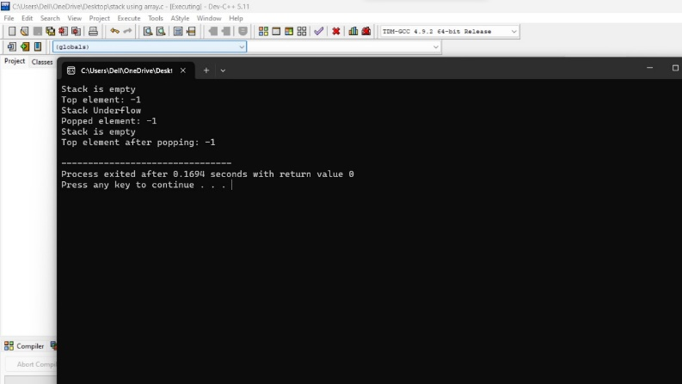

**PROGRAM-2**

Conversion of infix expression to postfix expression



OUTPUT:

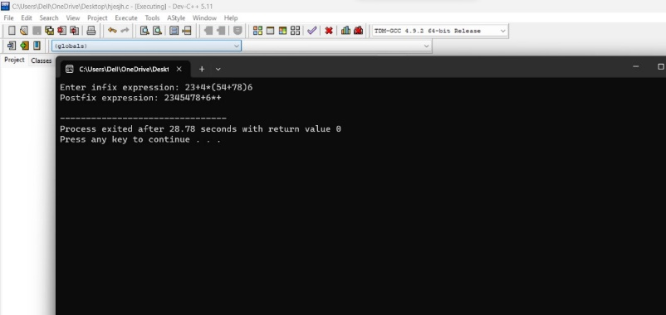

**PROGRAM-3**

Evaluation of expressions



OUTPUT:

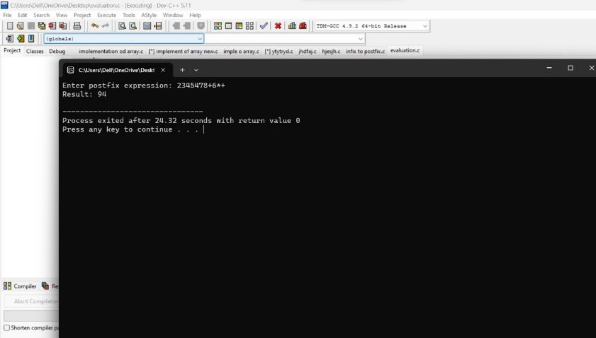

**ASSIGNMENT-1**

Tower of Hanoi is a mathematical puzzle where we have three rods

and n disks. The objective of the puzzle is to move the entire stack to another rod, obeying

the following simple rules:

**1.** Only one disk can be moved at a time.

**2.** Each move consists of taking the upper disk from one of the stacks and placing it

on top of another stack i.e. a disk can only be moved if it is the uppermost disk on

a stack.

**3.** No disk may be placed on top of a smaller disk

**4.** You can choose to use the function ***move(4, 1, 3, 2)****, w*here 4 represents the

number of disks. 1 represents disks on source shaft, 3 represents the destination

shaft which holds the disks after the move and finally 2 represents the

intermediate support shaft – temporary storage. Write a C program to simulate the

given problem and : Perform the algorithmic complexity analysis for the solution you

propose.



OUTPUT:

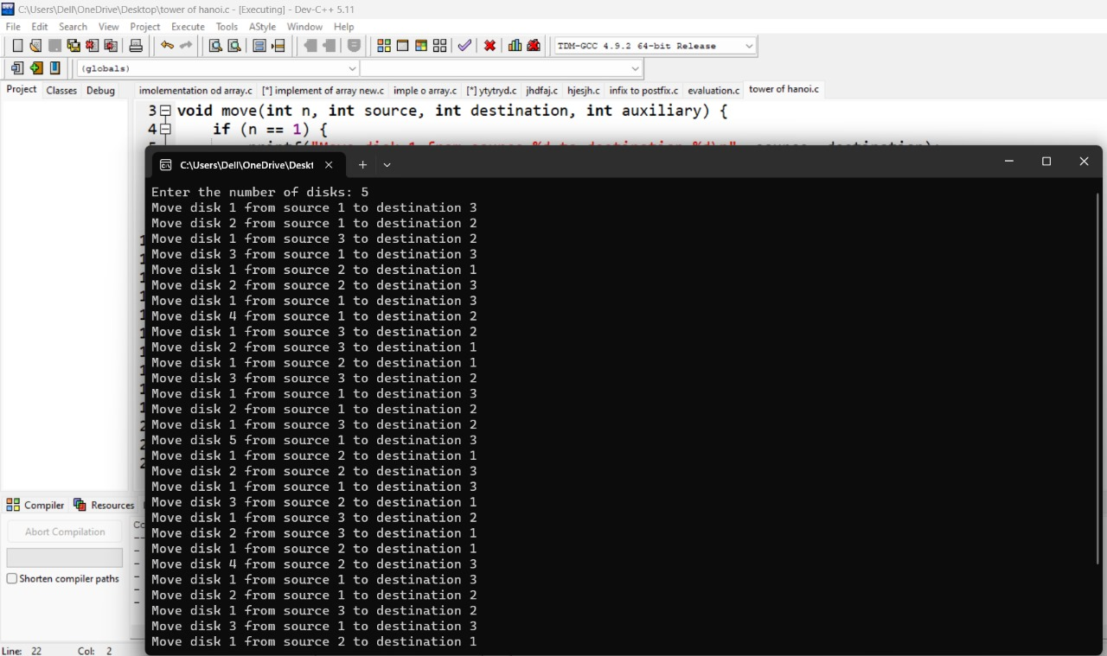

THE END